Alternative solution to 1aiv using difference lists (as suggested by examiner’s report):

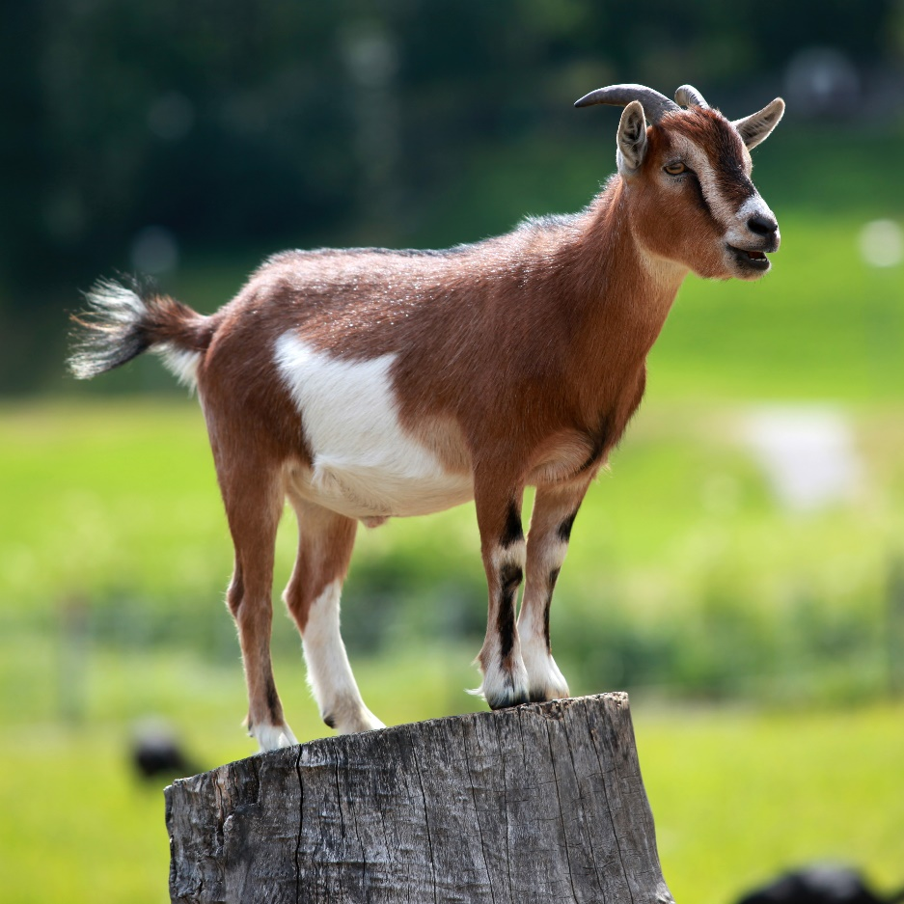

Mvp



data Tree a = Leaf a | Node (Tree a) (Tree a)

fromTree' (Leaf x) = [x]

fromTree' (Node lt rt) = (fromTree'' lt . fromTree'' rt) []

    where

        fromTree'' (Leaf x) = (:) x

        fromTree'' (Node lt rt) = fromTree'' lt . fromTree'' rt